6th Grade News
January 10, 2019

The Losers Club: Based upon students’ enthusiastic reaction to the Andrew Clements novel, The Losers Club, Ms. Mayone-Allison is offering an after-school reading club (by the same name). In the novel, Alec Spencer realizes he can start an after-school program that affords him the opportunity to read, read, and read some more. His hope is that by calling it The Losers Club, no one will join and he can happily read, quietly, by himself. But, students do join and Alec finds out that reading with friends is better than reading alone. Given the initial enrollment, Ms. Mayone-Allison is very excited to be facilitating this club!
Mark Your Calendar:
01/15/19 | Bennett (afternoon) PTA Meeting
01/21/19 | No School – Martin Luther King, Jr. Day
01/24/19 & 01/25/19 | Sixth Grade Field Trip to Albany
01/25/19 | End of Second Quarter
01/28/19 | Session Two of After-School Programs begins – check out The Losers Club book club, offered to 6th grade reading enthusiasts
02/01/19 | 2nd Quarter Report Cards issued
02/08/19 | Bennett Carnival

Upcoming Field Trip: At the end of the month, the sixth graders will be traveling to Albany to visit two museums! The Albany Institute of History & Art and The Albany Heritage Area Visitors Center & Henry Hudson Planetarium. Permission slips were distributed earlier this week, and should be returned to school as soon as possible!
Due to the size of our group, and the space limitations at both sites, students will be visiting on two separate dates. One half of the sixth graders will be going on Thursday, January 24th. The other half will be attending on Friday, January 25th. Inclement weather, causing a delay or school-day cancellation will require us to use the planned snow dates – Thursday, January 31st and Friday, February 1st.
Personal Belongings on the field trip: Students are responsible for their personal belongings. Pack light! Everything that your child brings on the trip needs to stay with your child during the entire trip! Having said that, “Yes, students may bring electronic devices,” however, we have specific stipulations:
- No cameras (most museums do not allow photos to be taken; several students do not have a “photo release form” on file; we do not allow picture taking on the bus)
- Headphones for electronic devices are a must
- The school will not take responsibility for anything that is forgotten, broken, lost, or stolen.

Important reminder: The trip requires an early morning drop off and late day pick-up! Students should arrive at school between 8:00 & 8:15 a.m. – no later! As soon as attendance is taken, we are heading for Albany!! Please note that students will also need to be picked up, as they will not return in time to take the afternoon buses. Our estimated return time is 4:00 p.m.
Money for the field trip: There is no need to send your child on this trip with money. We will not be visiting a souvenir shop, and there are no facilities for purchasing food.

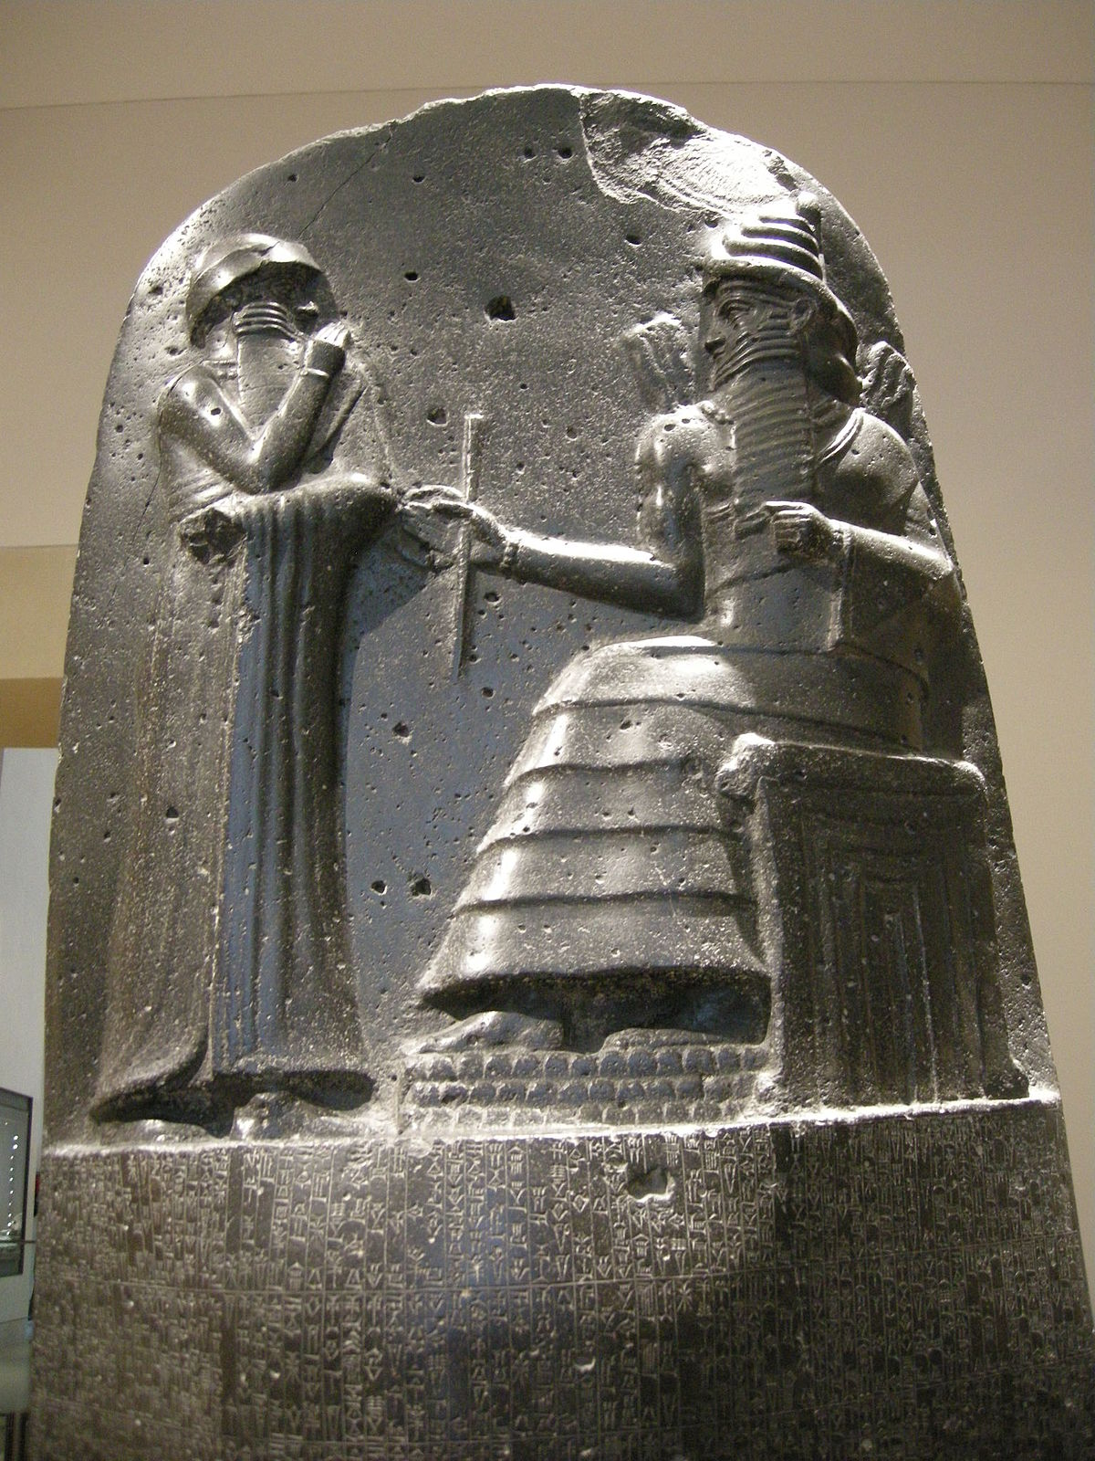
Food on the field trip: The State museums are “carry-in, carry-out” facilities. Students are not to bring glass containers or food that needs to be reheated. Again, there is no place to purchase food, so ensure that your child has breakfast before coming to school that day (students may or may not be able to eat on the buses – we have not received information from the bus company, yet). If your child receives free or reduced lunch from school and would like a bagged lunch prepared for the trip, please have them alert their homeroom teacher no later than Tuesday, January 22nd.
Social Studies: We have finished our unit on Mesopotamia and the Fertile Crescent (unit test was given on Tuesday, 01/08). “I think the students’ favorite activity was discussing Hammurabi’s Code of Laws. There is just something about an eye for an eye or a tooth for a tooth that really gets them excited!” Mr. Downs reported.
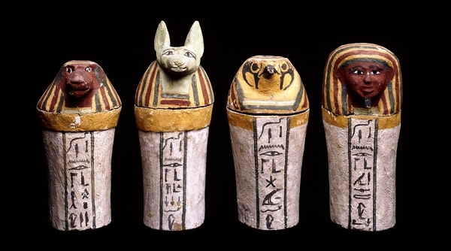
We are moving to the Nile River and Egypt. This is a fascinating topic to study, as we get to learn about the pharaohs, pyramids, and of course, the art of mummification. There is a continuum in the study as we move from cave painting to cuneiform written on clay tablets to hieroglyphics and the use of papyrus by scribes. “I am really looking forward to sharing this unit with your student as it includes our upcoming field trip to a museum in Albany,” Mr. Downs added. “There, they get to see an actual mummy, complete with organ jars!”
Science: WED. . .not an abbreviation for Wednesday (Woden’s Day), but a mnemonic for Weathering, Erosion and Deposition. We are expanding our look into the ways Earth’s surface changes. From river systems to frost cleaving, we will look at Earth as dynamic rather than static. Students should be accessing information directly from the textbook whenever completing homework assignments.

Writing: The last few weeks in writing we have worked with narrative and personal narrative writing. Each time we write, we are trying to inject more life into our writing, using figurative language, character traits (that express and reinforce feeling, emotions, and experiences), varying dialogue – that not only matches the personal style of the speaker, but to also make it interesting to our reader. Recently, we used Dan Greenburg’s My Superpowers to choose a super power of our own, as well as a situation in our lives that this superpower might have been used to change the outcome. Some of our superpowers were pretty stereotypical, such as flying, teleportation, and invisibility. Others are more unique, such as speaking and understanding any language, or being able to insert themselves into a story. By this time in the year, students should comfortably be writing at least 1 ¾ to 2 pages in their journals for each prompt. They should also be writing with appropriate paragraphing and showing each of the skills we’ve reinforced this year. Many students still come to class unprepared quite frequently, having not completed their writing from the previous class. It is truly important to come prepared and stay current in writing. The only way to improve, is to write. Chronically unprepared students do not progress at the rate they should, and often lose out on opportunities to work with partners to gain feedback on how to push their writing. These writing skills are then reflected in all core subjects.
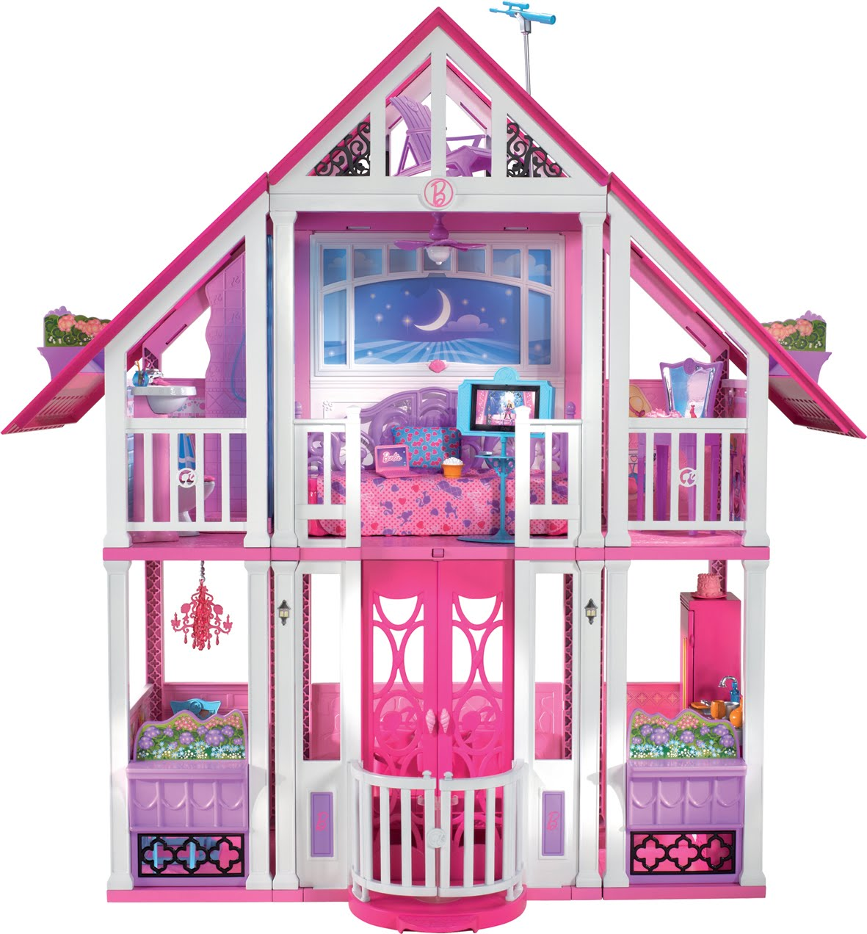
Math: Students are exploring with shapes. They are finding the perimeter and areas of quadrilaterals, triangles and parallelograms. Students are being exposed to the real world application of these skills in housing designs, as well as landscape architecture. Irregular shapes are also being introduced to allow students to problem solve missing dimensions. Incorporating the balancing of equations has fostered a connection between geometry and finding the area of shapes. In the near future, students will be designing floor plans for their dream houses using scale. Then, they will find out what it will cost to build.
Reading: We are now in Bend Three of our Character Unit. Bend One invited readers to think more deeply about characters – how they act, react and interact; what they say, do, and think. Students examined how internal and external pressures affect characters; they also gathered text evidence that confirmed or changed their initial ideas about characters (with a willingness to revise their thinking). The sessions in Bend Two required readers to think more critically about how setting affects characters – how the mood of the setting can drive the action, influence how characters interact, and further develop the plot, conflicts, and story resolution. Our sessions in Bend Three explore motifs – story elements such as images, sounds, actions, objects, ideas – that lead readers toward understanding the themes and lessons that authors are teaching through their stories. Students should be following their individualized reading plan, setting aggressive goals for themselves, and reflecting in their reading journals each night that they read.

