Welcome to Reading in 6th grade! The purpose of this newsletter is to provide an overview of the reading program, which is slightly different from what has been expected of your child in the past. Hopefully, this information will answer any, and every, question you may be asking your child about reading – the requirement and expectations that will lead him/her toward academic success, as well as foster a love of reading!
Reading, Explained
2018-2019 School Year

Expectations for student preparedness: These materials should be with students every day in class.
- Log/calendar – distributed/collected at the beginning of every month. Students plan their books prior to reading.
- Binders – a series of mentor texts (fiction and non-fiction), as well as handouts should be housed
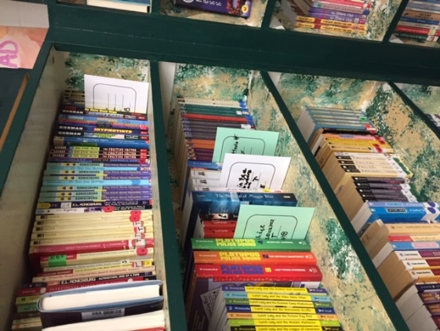
- Reading Journals/Notebooks
- Current just right chapter book/novel

Where do students get their books? Students were all given two “library cards” that can be used to borrow books from any of the 6th grade homerooms. Students should borrow one book at a time. The cards are used to record the book title, author’s name, and the date on which the book was borrowed. The card is placed on the shelf, in place of the book, so students know exactly where to return the book. Students can also get books from
- School library
- Public library
- Personal collection at home
The reading level of a book can be obtained through perma bound, scholastic, or by “googling” guided reading level of (insert book title)

How do students use their logs? The calendar/log is two-sided. It is a useful tool for students to plan and record their reading, as well as set goals. NOTE: Students are required to plan each book before they start reading – this is key to helping them develop their plan for reading, setting attainable goals and monitoring their own progress as readers. We do not set “time” goals. Students are expected to set goals for the number of pages they will read each night – the Teachers College Reading Workshop program sets aggressive goals for reading. Realistically, we know that these goals are attainable; we also know that our students have busy lives. With support, we expect them to grow as readers, but our ultimate goal is to help them foster a love of reading.

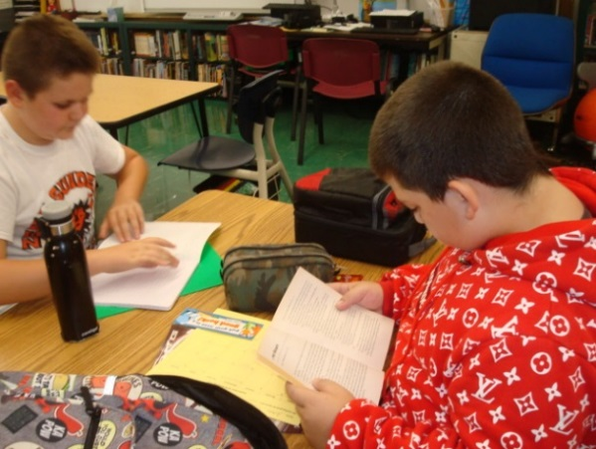
How do students plan their reading? When we set up our first calendar (September), students were asked to fill in the days that their commitments would prevent them from reading a higher number of pages (see the example below, and on the next page). If students need to miss reading completely, or choose to give themselves a “night off,” we stress that they should avoid taking more than one consecutive night off each week; this can easily disrupt the flow and understanding of their books. Reading a fun book is okay, once-in-a-while. For instance, if a student finished a novel over the weekend, and forgot to get a “book on deck,” a fun book or magazine is a great way to keep their eyes on text! My hope is that students read every night, seven days a week, but I know that life happens, and having that expectation “hanging over one’s head” does not support a positive reading life; if anything, it will discourage it. However, writing about reading should happen every time a student reads, with approximately a page (or more) of written reflection.

Students were required to have chosen a book on/before Friday, September 7th. They were required to record the title, author, and number of pages, and were given a two-week (quite lenient) window for completing their books; students were given the following prompts:
1 – Find the number of pages that your book has.
2 – Decide on the number of nights it will take you to read your book.
3 – Divide the number of pages by the number of nights, to see how many pages you would be to read to complete your book by the chosen date. (This can also be done using the number of pages at the divisor)
4 – Now, you shouldn’t be stopping in the middle of the chapter, so you need to adjust your pages to ensure that you finish, each night, at the end of a chapter (It only makes sense! Besides, if you’re not used to stopping and jotting while you read, at the end of the chapter, you should have plenty of ideas about which you can write.)
5 – MODIFICATION TIME! Check the number of pages you plan to read against the goals for your reading level. . .too aggressive? Modify! . . .not aggressive enough? Modify!
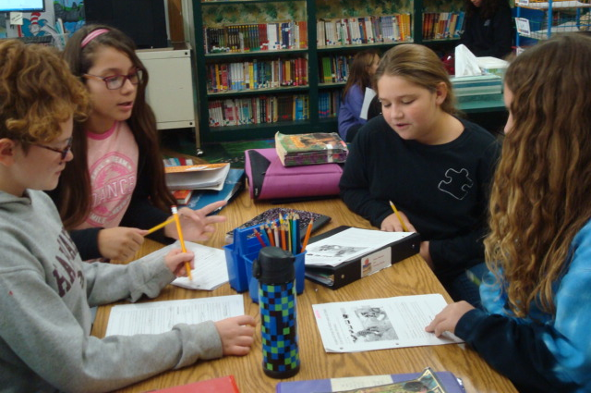
6 – Your reading goals should be set before beginning any novel. Remember, you aren’t recording what you read, but what you plan to read. On the side of the log that looks like a calendar, you can place a check mark (√) on the days that you met your goal and/or the exact number of pages you read (rather than the range that was placed on the planning side). It’s okay to make revisions, just record them! At the end of the month, you can look at your progress – did you achieve your goal? Did you grow, increasing your volume and stamina? By the end of September, unless students are reading books that are over 500 pages long, every student should have completed at least one book. Nightly reading and written reflections are now a requirement.

On what do students reflect? With each year, the books students are reading are becoming more complex; therefore, the expectations regarding their reflections require them to think more deeply. Sixth graders should be investing the time needed to write at least a full page (or more) about their “thinking while reading.” They should be utilizing the strategies and tools that showcase their thinking. The way students reflect and what they choose to reflect on, is very individual because reading is different for every reader. Since students are managing their reading time, they know to write every time they read.

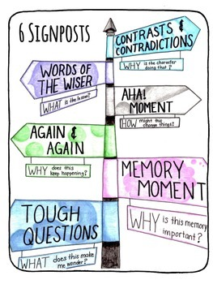
How is the reading journal/notebook organized? The front of the notebook includes smaller handouts that students can reference while writing about reading, as well as students’ class notes. The second half of students’ notebooks are titled Read Alouds. This section is used for students’ reflections during homeroom and reading class “read alouds.” Along with the short stories, excerpts, and texts read in reading class, there are novels that are read during homeroom. These novels, like the other texts that are read aloud, are referenced frequently to teach various concepts and reading strategies. Coming to class prepared promotes on-going student success.

We recently completed the introduction of fictional signposts. The signposts are six features that appear in every young adult novel – they are noticeable points in a text that almost demand “…that the reader pause and reflect, notice them and make note of them…the more students noticed these signposts, the more they were using the comprehension processes: visualizing, predicting, summarizing, clarifying, questioning, inferring, and making connections.” (Beers & Probts, Notice and Note Signposts for Fiction, pgs 68-69)

While students continue to focus on independent reading of fictional books, we are now introducing the non-fictional signposts. These signposts also provide students with the noticeable stopping points that lead to deeper understanding, only with non-fiction texts. The homeroom read alouds will continue, as will note-taking, the use of digital texts, and the introduction of a variety of fiction and non-fiction texts to help students practice using the signposts, as well as more handouts. As the quarter winds down, notebooks will again be collected and reviewed, and students will receive a November reading calendar/log (each new log contains more and more information, intended to inspire students’ reflections).

