6th Grade News
November 15,2019

Tools For Success: Our overriding goal for sixth grade is to support students as they take on a more independent and proactive role in their academic life. In addition to homeroom assignment boards, students are expected to use their nightly planners to record their homework. Students have numerous opportunities for realizing and maintaining success:
- Student Support Time – other than (the one day each week) when one of the homeroom teachers has playground duty, we are available to provide student support at recess time.
- Band-Orchestra-Chorus – two days-a-week, a number of students participate in one of these activities. The students who remain in the classroom are encouraged to take advantage of that time to work on homework and/or get help from a specific teacher, in whose subject area they may need additional help.
- Homework Program – four days-a-week, students can attend this after-school activity. Two sixth grade teachers facilitate this program, assisting students with work completion – often, one-on-one or in small groups. Students who participate and take advantage of this time often leave with little-to-no remaining homework.
- Taking Advantage of Re-Dos -- Students have been reminded, numerous times, that if they are unhappy with the results of their efforts on independent assignments, they should redo and resubmit. Reviewing graded work, and correcting errors is a valuable learning experience. In many cases, the grade earned can be adjusted to reflect students’ efforts.

Speaking of Homework: Students who make full use of school hours should not feel overwhelmed with homework. Many assignments are started, and often, completed in class. With the exception of reading and writing-about-reading, the workload is really not intensive. As for writing-about-reading, students should make aggressive reading goals – focusing on “number of pages,” rather than time. However, when they are done reading, students should be investing approximately 10% of their reading time into writing-about-reading.

Mark Your Calendar:
DATE | EVENT
11/15 | 1st Quarter Report Cards issued
11/21 | Thanksgiving – Senior Luncheon
11/21 | PTA Afternoon Meeting (3:45)
11/22 | Bennett Picture Retakes/Make-up
11/27 – 12/01 | Onteora School District is CLOSED; Thanksgiving Weekend
12/09 | Bennett Holiday Boutique Begins
12/18 | Bennett 5th-6th grade Winter Concert (snow date – 12/19)
12/21 – 01/01/20 | Winter Break – NO SCHOOL
01/02/20 | Happy New Year – Classes resume

In Math, we are balancing algebraic using all four operations. The equations consist of decimals and will transition into balancing equations with fractions. A quick review of addition and subtraction of fractions will be followed by multiplying and dividing fractions. Once students are feeling comfortable with this tool, the class will be introduced to word problems such as calculating the length of an object when give the width and the area. Kids have been practicing in class and have been using Versa-tiles, which allow students to self-assess.
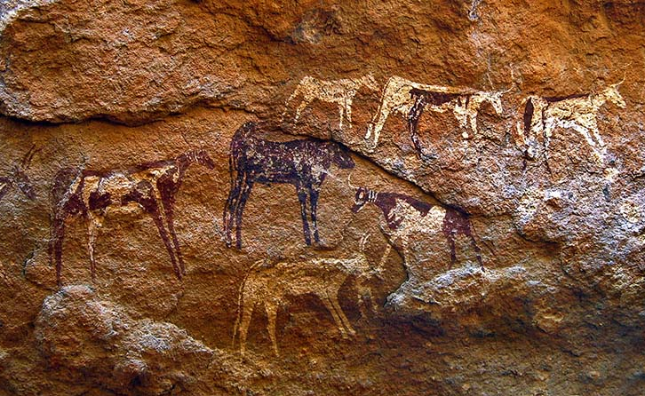
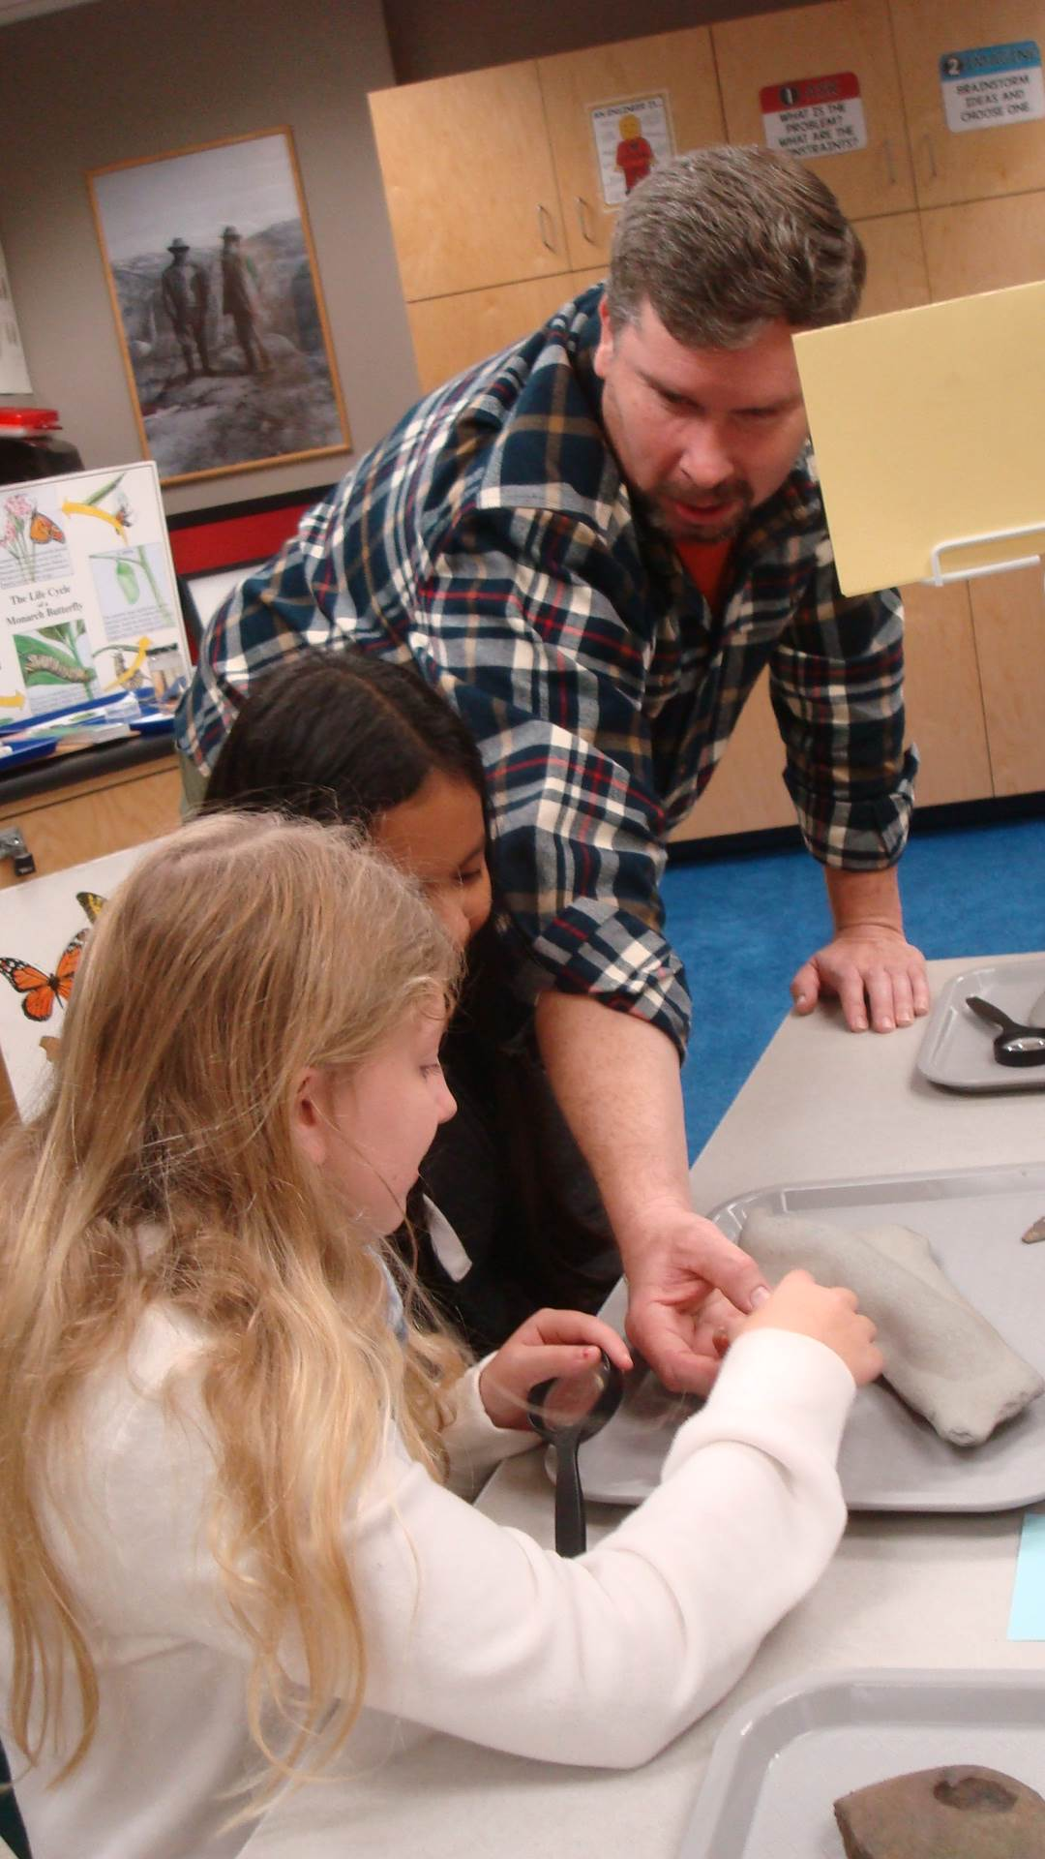
In Social Studies, students are engaged in lessons and activities about early man – from the Paleolithic to the Neolithic Era. Students are learning about how civilizations rose due to the shift from nomadic hunter-gatherers to agriculture. Recently, students participated in an archaeological workshop with Mr. Matt Savatgy, our scientist-in-residence. Students explored objects at various stations – examining artifacts and discussing how these objects may have been used by early man. They also classified objects, determining which category they belonged to – rocks, fossils or artifacts.
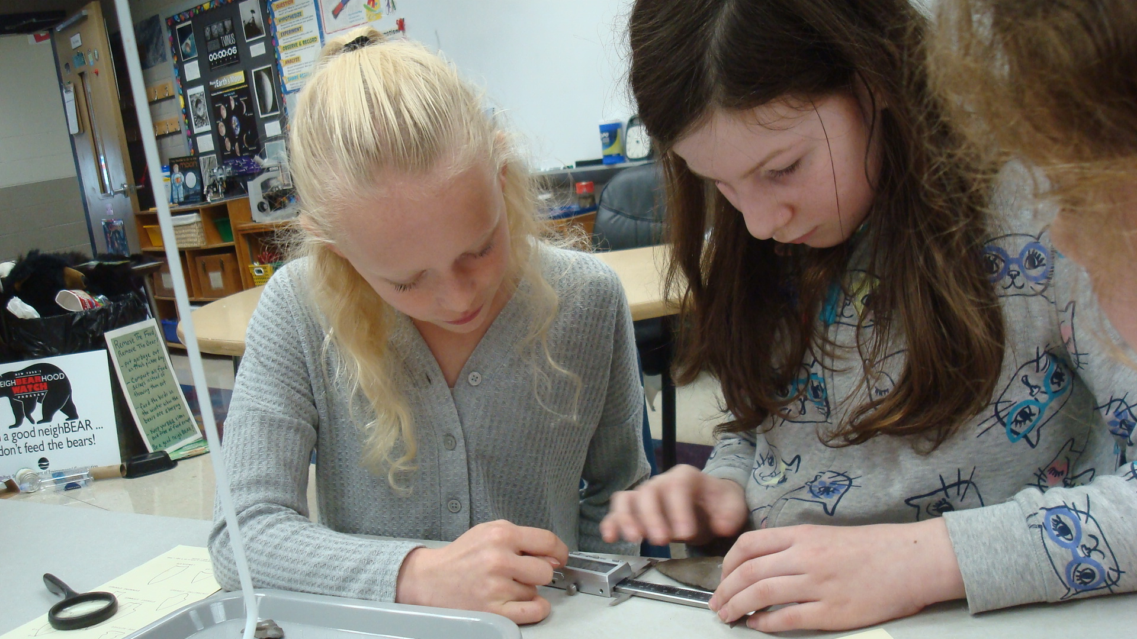

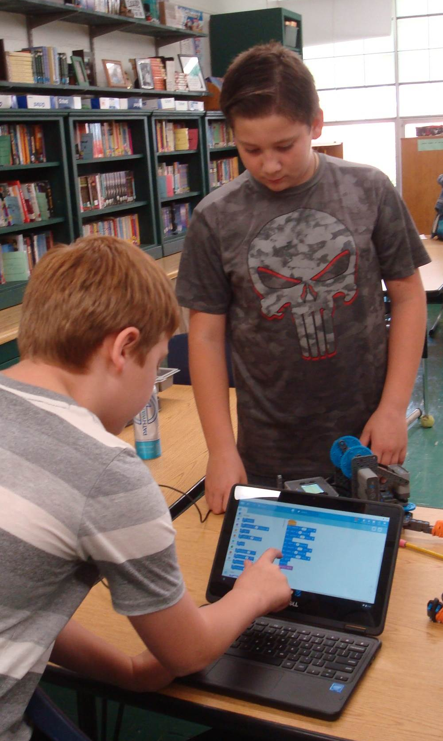
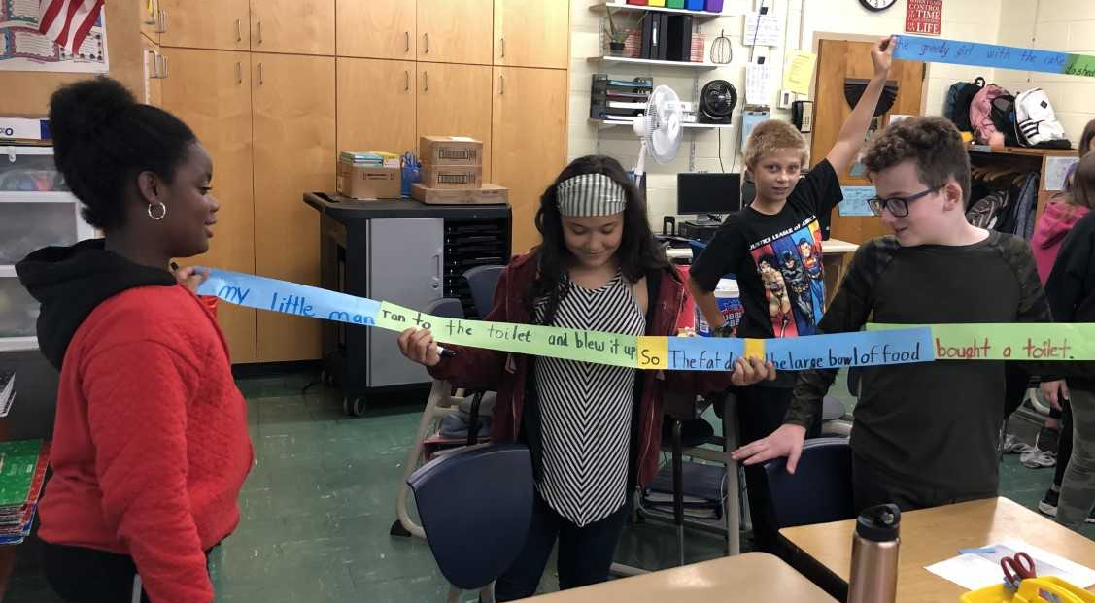
In Science, Mr. Downs reports, “The end of the first quarter brings the end of our robotics unit.” This week, student have participated in a school scrimmage of the VEX IQ Squared Away Challenge. “I have been so proud of the growth I’ve seen in the students this quarter,” Mr. Downs added, “robotics is hard. The Squared Away Challenge is hard.” Students also learned that in order to be successful they had to work together and persevere. It has been a great experience for all.
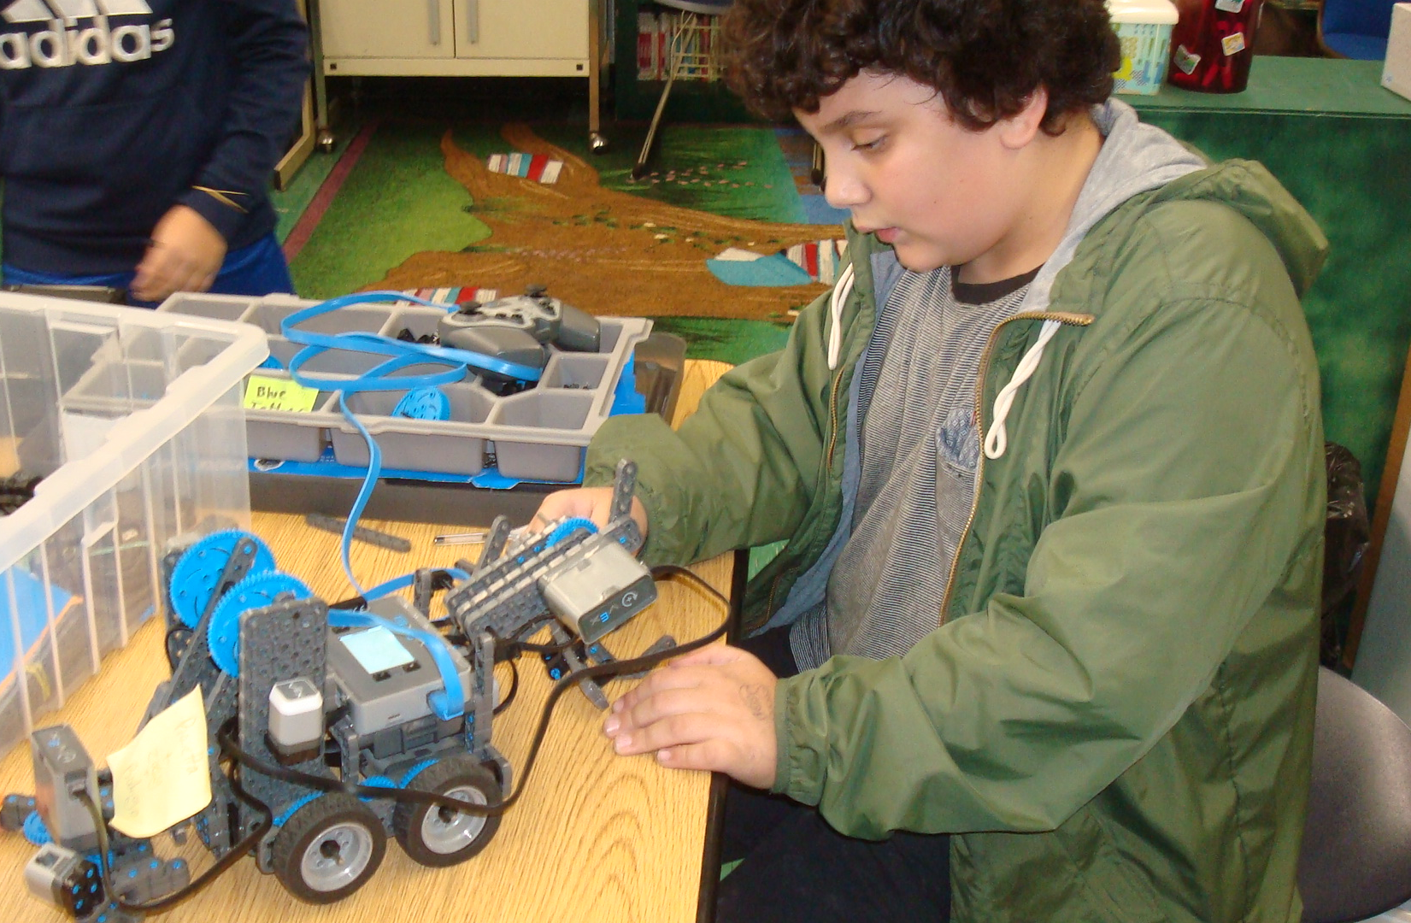
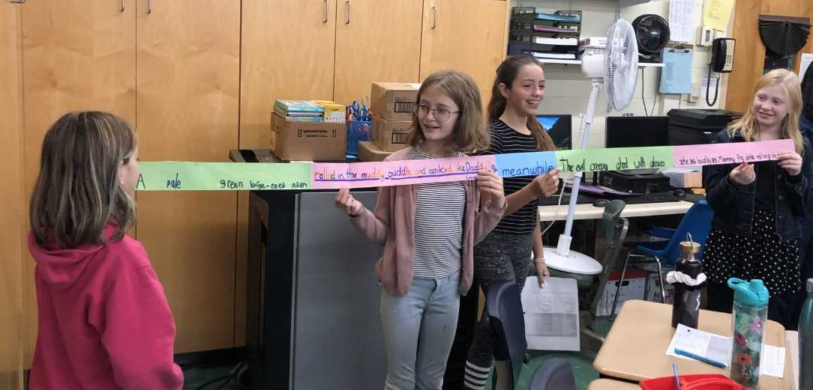
In the coming weeks, we will be breaking down our robots and inventorying the pieces. This is a large task that also teaches students the importance of taking care of their equipment. We will then be moving into a unit on Earth’s resources. In looking at renewable and nonrenewable resources, students will gain an insight into the true importance of the conservation of materials. As always, this unit will contain a project designed to get our students thinking, working together, and it will provide them with the opportunity to be successful beyond paper and pencil assignments.

In Reading, we are still in our character unit – expanding our tool box of strategies and skills. Students are all reading just-right chapter books (please, no graphic novels, biographies or non-fiction for this unit). They should be planning their novels before reading – challenging themselves to increase the number of pages that they are reading each night. In doing so, they are increasing their stamina, as well as setting attainable reading goals. Students should also be reflecting on their reading each night that they have planned to read. Of course, students can take “buffer nights” – a night when they allow themselves to take a night off from reading their just-right-books. However, buffer nights do not exempt students from homework that may be assigned on that night. “All-in-all, I am pleased with the progress that many students are making,” remarked Ms. Mayone-Allison. “The students who consistently read and reflect are able to realize success – both in their grades and their increasing reading levels.”

In Writing, we ended our first quarter with a solid foundation in writing conventions. All of the work that we've done with vocabulary, transition words and phrases, punctuation, using sensory details, show-not-tell, and creating complex sentences will now be the basic criteria for all writing moving forward. We've even had some fun activities where we constructed the parts of a simple sentence (subject, predicate), added a transition word or phrase to make it a complete thought, and made some really wacky sentences together. Our objective was to be able to adjust our sentences so that they had all of the pieces of a complex sentence, and showed a complete thought. Keeping up with our writing is a goal that students should have daily. Some students are coming to class unprepared, and do not complete their writing pieces. This has a true impact on the progress they are able to make. Students are given time in class to start their writing. They also have resources to which they can refer while writing. Using time and the provided resources to their advantage, is an important part of a student’s job. The only way to improve in writing is to write. We're starting personal narrative and narrative work, using all of the core writing conventions we've worked on throughout the quarter.

