6th Grade News
November 30, 2018

Second Quarter Work Habits: It feels like we had just got into the routine, and Halloween was here! Now, December is (literally) tomorrow! November went by in a flash – we had Parent/Teacher Conferences, report cards, Senior Citizen holiday feast, Thanksgiving break, and our first snow day!
With the second quarter underway, we want to address academic expectations and students’ work habits. Students who were pleased with themselves, and the grades they earned (as reflected on the first quarter report card), should continue putting forth the same high level of effort. Those who weren’t pleased, should work towards regularly utilizing the tools that will lead to success – the assignment boards, planners, and take-home folders.
Due to the holidays and winter weather, the second quarter can often be a challenge for some students. Students need to be consistent in work completion, and take advantage of opportunities for revision.

Word Study: We continue to have a two-week cycle. Students are introduced the vocabulary, with its unique spelling pattern, every other Monday. Throughout the two-week period, there are several homework and classwork assignments. At the end of the cycle, students are tested on both the words from the initial list, as well as other words that follow the same pattern. The words can be found on our grade level website.
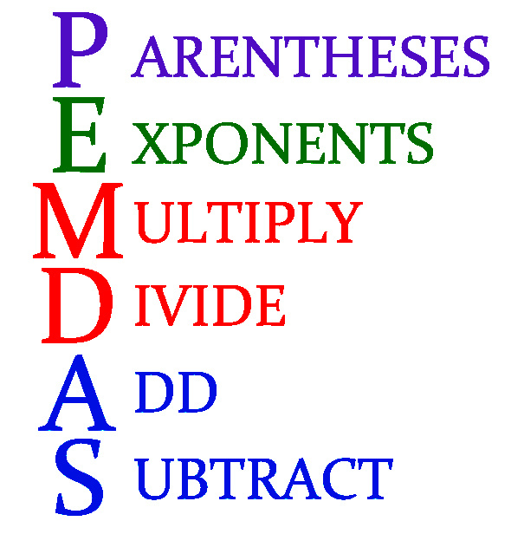
Math: Students are working on calculating all operations with decimals. This will be the preparation for orders of operations with decimals. We are continuing our math workshop by creating a connection between our hands-on activities and figuring out percentages. The students have been introduced to a double sided number line that will be a “go to” tool for problem solving percentages and rates.
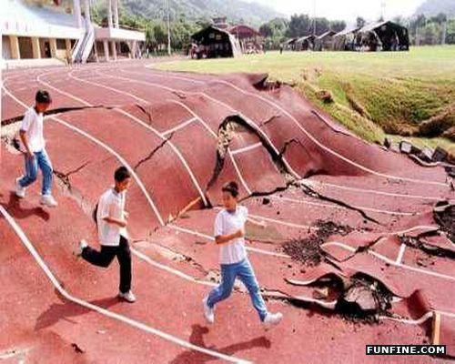
Science: Earth-quacks, pilates, volcan-ohs, plate boundaries, epic-enters, focuses….how an earthquake makes a big “boom-boom!” Lots of vocabulary came pouring out (like lava), when students were asked what they were learning in Science class. Bottom line – it’s Earth Science, not their fault!

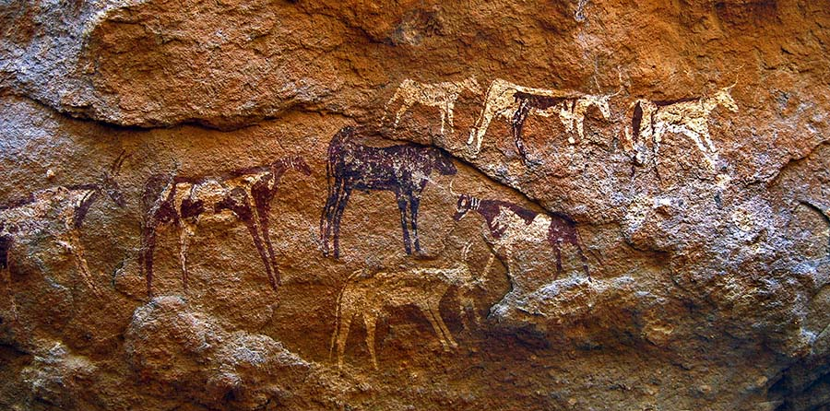

Social Studies: We’ve had an exciting time in Social Studies traveling back through the Paleolithic and Neolithic Eras.
Following an open-note quiz on Friday we will be diving headlong into the world of Mesopotamia. We will be looking at their use of technology in creating levees and irrigation systems. Their improvement on farming techniques and some of the issues they faced. We also get to explore cuneiform, which is one of the first known writing systems of the world.
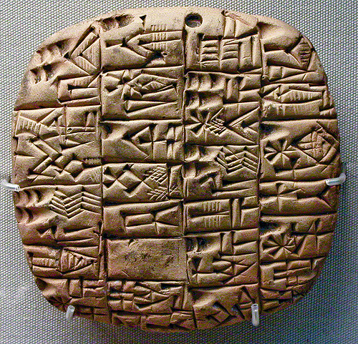
This will allow us to include a few topic-based activities that will make the learning more enjoyable. We also get to begin learning about individuals, something we couldn’t do in the Stone Age. With characters, such as Gilgamesh, Hammurabi, and Solomon, it should make for interesting discussions throughout the unit. We are planning on completing this unit prior to winter break, so there will be a unit test in the next few weeks.

Former Bennett Students + BOC time + Homework Club = Community Service:
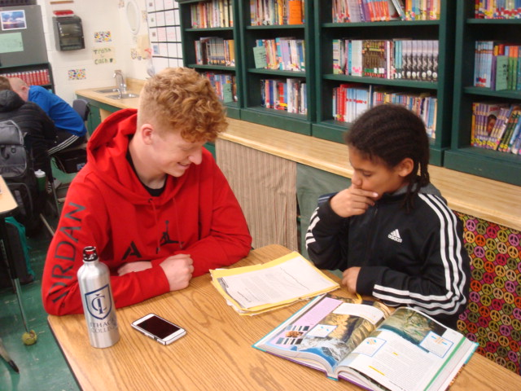
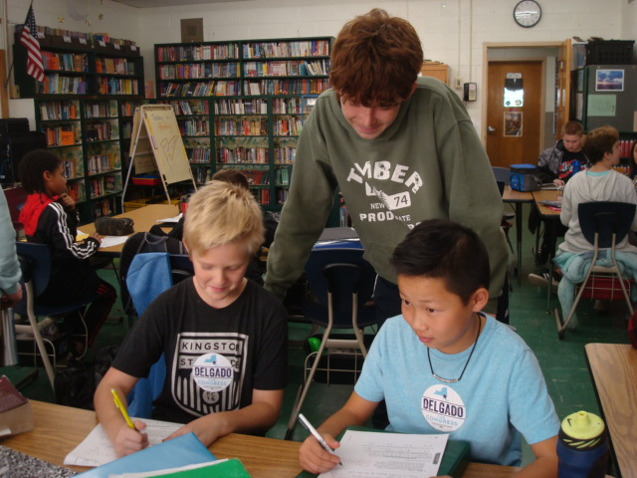
Elie Kuhne and Frankie Parslow, both former Bennett students and Onteora High School seniors, are giving so much more than they’re getting. In exchange for community service hours, Elie and Frankie have been coming up to Bennett to assist students with their homework during Band-Orchestra-Chorus (BOC) time (Tuesdays and Fridays from 2:45 – 3:25) and during the After-School Homework Program. Students are always
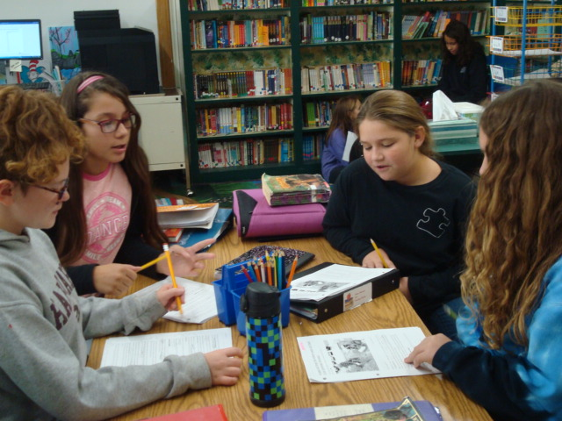
excited to see them, and appreciate their help and support.

Mark Your Calendar:
12/10 | Bennett Holiday Boutique Begins
12/11 | Bennett PTA Meeting (3:45 p.m.)
12/13 | Bennett 5th – 6th grade Winter Concert
12/22/18 – 01/01/19 | SCHOOLS CLOSED – Winter Break

Reading: This week, we began our latest unit – A Deep Study of Character. Students are learning to consider more complex character traits, to investigate how setting shapes characters, and to analyze how characters are a vehicle for themes. Students are encouraged to think more deeply about the characters in their stories. One instructional method that is being used is the read-aloud. It is lively, fast-paced, and aimed at engaging students immediately, in raising the level of their reading work. There has already been a visible (and audible) improvement in the level of students’ conversations about books. To see students transfer their great ideas to their notebook entries would further lift their level of thinking about their books.
Students are still in control of their reading lives, planning each new book on their reading calendar/log, setting realistic goals and an aggressive pace for completing their novels. Students are reminded to write, every time they read. Coming to class, every day, prepared, ratchets up the level of conversation. Students should be bringing their calendar/logs, novels, reading journals (notebooks), and binders to class every day.
Today (November 30th), students’ November logs were collected, and they received their December logs. Planning their books helps them set attainable goals. Students are reminded that they shouldn’t go more than two consecutive days without reading, as it interrupts the flow of their book. Part of self-planning includes knowing that when reading at night feels almost impossible, deciding to use recess time to get work done is a great pro-active way to set and maintain high academic standards. Also, today, students engaged in a gallery walk – sharing their reading journals with peers. It is a great way for students to offer additional support to one another as readers.

Writing: The last few weeks in writing we've been focusing on personal narratives - true stories, about us, told from our point of view. We've been working on teasing out character traits in ourselves, as well as others involved in our experiences, as well as incorporating dialogue that gives further insight into our experiences. We'll continue working on personal narratives, as well as narrative work throughout the Month of December.
It's important to remember that in order to make progress in writing, you actually have to write. Students are given ample time in class to work on their writing, and then should finish their pieces if they did not finish them during class time. Many students are not finishing their work, which puts them at a disadvantage. They are not then able to share their work, get feedback, and deprive themselves of making the progress they are capable of making. Our minimum of one and three quarters journal pages is appropriate, and students should be setting higher goals for themselves by this time in the year. You have to practice in order to improve.

